Training workshop on emerging infectious diseases – 2026 - Istanbul

Onsite courses
This workshop will be held in Istanbul in March 2026 and will last for two days. Through an exchange of experiences between clinicians, issues relating to the management of CCHF, dengue and West Nile infections will be addressed.

25th and 26th March: from 9 am to 5 pm
Venue: Double Tree by Hilton - Istanbul Topkapi

Sponsors and supports
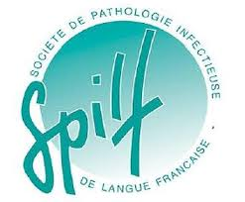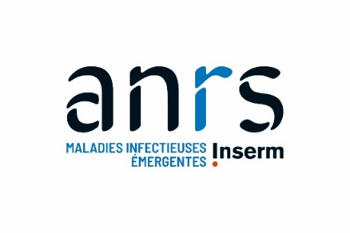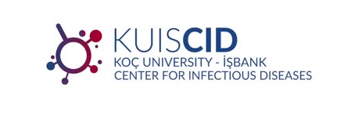

Organizing/Scientific commettee : Önder Ergonul, Nurcam Baycam, Octavio Arce, Marta Mora Rillo, Simon Bessis, Jean-Marc Chapplain.

Day 1 | 25th March

8.30 am | welcoming participants

Introductory lecture and Workshop opening
9 am | Official opening, presentation of the programme and objectives  Koç University Onder Ergonul  Sociedad Española de Enfermedades Infecciosas y Microbiología Clínica  Société de pathologie infectieuse de langue française – Groupe Emergence –JM Chapplain and S Bessis  Coordination du Risque Epidémique et Biologique - X Lescure

West Nile Virus Disease in Europe: Emerging Trends and Clinical Challenges
Chair: X Lescure and JM Chapplain
9.45 am | Epidemiology in Southern Europe: Current Landscape and Future Risks  Francesco Vairo (Italy)
10.15 am | State of the art in case management – lessons from the field in Italy  Emanuele Nicastri (Italy)
11.15 am | From First Cases to Persistent Transmission: The West Nile Virus Journey in Spain  José Miguel Cisneros (Esp)
11.45 am | Round Table: Sharing Clinical Experiences  All previous speakers

12.45 pm | Lunch Break

Dengue Virus: Emerging Challenges and Clinical Insights
Chair: J Membrillo de Novales and D Malvy
2 pm | Spain’s Experience in Dengue Management: Clinical and Public Health Approaches  Marta Diaz Menendez (Sp)
2.30 pm | State-of-the-Art Management: Current Strategies and Future Directions  Francesca Norman (Sp)
3 pm | French Experience from the continent: management of indigenous cases in continental France  Michel Carles (Fr) - Online presentation
3.30 pm | French Experience from the Overseas Territories: outbreak response from the field.  Vincent Ronin (Fr)
4 pm | Epidemiology and Pathophysiology: Understanding the Dynamics of Dengue  Alfonso Rodriguez Morales (Vz) – Online presentation
4.30 pm | Round Table: Sharing Clinical Experiences  All previous speakers
5 pm | End of the day – Social event

Day 2 | 26th 2026

Crimean-Congo Hemorrhagic Fever: Epidemiology, Clinical Management, and Control Strategies
Session 1: Understanding the Disease
Chair: S Bessis (Fr) and M Mora (Sp)
9 am | Epidemiology and Pathophysiology: State of the Art  Onder Ergonul (Tr)/ Anne Rimoin (US)
9:30 am | Clinical Insights from Turkey: Lessons Learned from more than 20 years of experience  Nurcan Baykam (Tr)
10 am | Hyalomma Ticks and CCHF: Predicting Disease Expansion Through Vector Ecology – Spanish and Turkish experiences  Francisco Ruiz-Fons (Sp) and Ayşen Gargılı
10:30 am | Discussion
11 am | Break

Session 2: Three pillars of CCHF treatment.
Chair: J Membrillo de Novales (Sp) and N Baykam (Tr)
11:30 am | Antivirals. Current Evidence and Scientific Literature  Önder Ergönül (TR)
11:50 am | Anti-inflammatories. consensus from Turkey  Handan Alay (TR)
12:10 pm | Optimizing Supportive Care: Lessons from Other Viral Hemorrhagic Fevers  Simon Bessis (Fr) / Denis Malvy (Fr)
12:40 pm | Discussion: Specific Treatment Strategies – Promise or Illusion?
13:30 | Lunch

Session 3: Infection Control and Diagnostic Challenges
Chair: Şiran Keske (Tr) and JM Chapplain (Fr)
14:30 pm | Turkey’s Experience: Protective Measures and Infection Control  Esma Eryılmaz (Tr)
15 pm | Spain’s Experience: High level Isolation Units model  Octavio Arce (Sp)
15:30 | Discussion

Chair: D Malvy (Fr) and Aysel Çelikbaş (Tr)
15:45 | Turkish Organisation for Diagnostic Management  Mert Kuşkucu (Tr)
16:10 | From Suspicion to Specific Care: Spain’s National Pathway for CCHF Management  Javier Membrillo de Novales (Sp)
16:30 | Diagnosing CCHF: Why a Challenge?  Delphine Pannetier (Fr)

17:00 Closing session – Why moving forward all together?
Turkish, Spanish and French learned societies representatives

